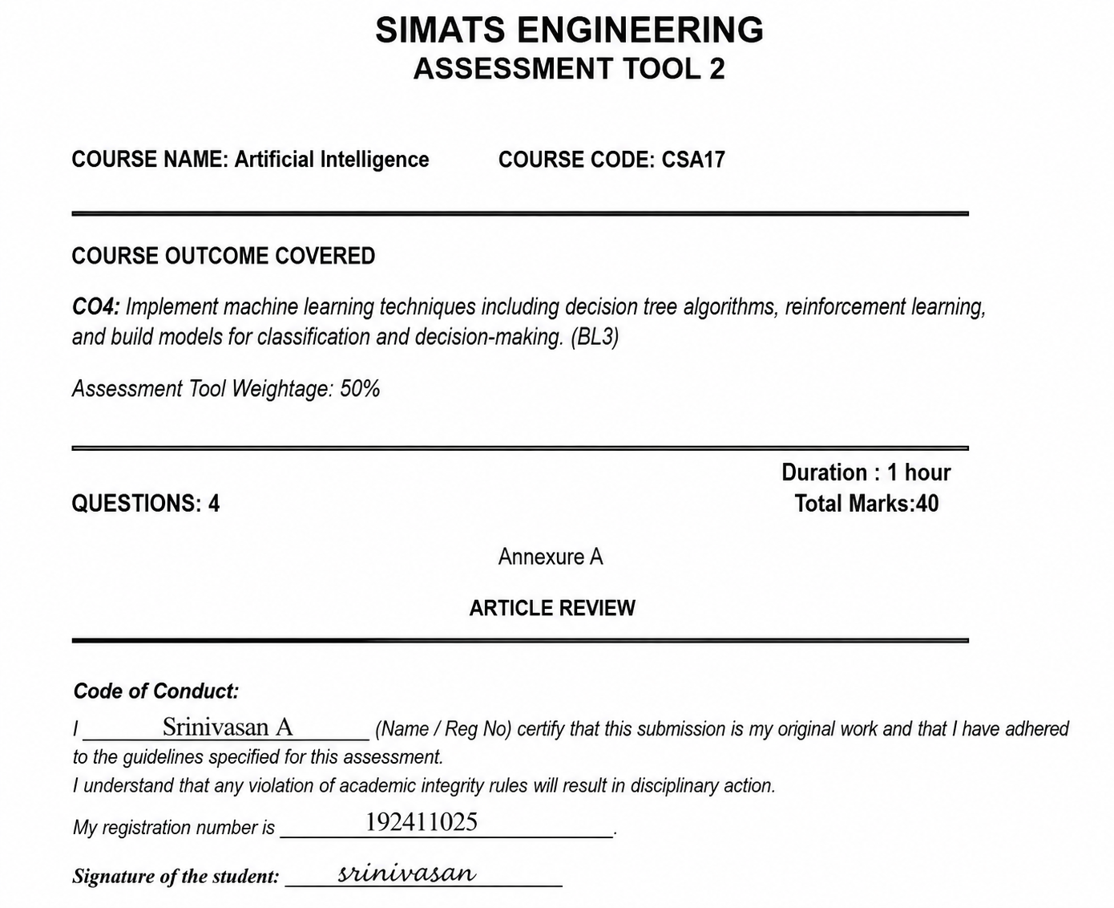

TASK 1: ARTICLE SUMMARY
(a) Citation, Domain and ML Problem
Full Citation
Bodine, J., & Hochbaum, D. S. (2022). A Better Decision Tree: The Max-Cut Decision Tree with Modified PCA Improves Accuracy and Running Time. SN Computer Science, 3, 313. https://doi.org/10.1007/s42979-022-01147-4. (Springer)
Domain/Application Area
The article belongs to the Machine Learning, Data Mining and Classification domain.
Specific ML Problem
The authors address the limitations of traditional CART decision trees using Gini impurity, especially when the dataset is:
- High-dimensional
- Large in size
- Multiclass
- Computationally expensive to process
They propose a modified decision-tree approach called Max-Cut Node Means PCA, which combines a new Max-Cut splitting criterion with locally computed PCA representations. (Springer)
(b) Key Objective and Research Gap
150–200 words
The main objective of the article is to improve the accuracy and computational efficiency of traditional decision trees, particularly for large and high-dimensional classification problems. Conventional CART decision trees commonly use Gini impurity to select splitting points. Although these trees are easy to interpret, their performance can decrease when the number of features or classes becomes large. The authors identified a research gap in developing decision-tree methods that can maintain interpretability while improving classification accuracy and reducing computational cost. To address this gap, they introduced two modifications. First, the Max-Cut splitting criterion replaces the traditional Gini impurity measure and attempts to create better separation between observations belonging to different classes. Second, Node Means PCA creates locally meaningful feature representations at each decision node rather than applying a single global representation. The combination of these methods produces the Max-Cut Node Means PCA decision tree. The authors evaluated the approach using extensive synthetic experiments and real-world datasets including MNIST, CIFAR-10, CIFAR-100, Iris, Wine Quality and Indian Liver Patient data. Their results showed substantial improvements, particularly for high-dimensional datasets. (Springer)
TASK 2: METHODOLOGY ANALYSIS
(a) ML Techniques Used
The paper focuses mainly on Decision Tree induction.
1. Traditional CART-Gini
The baseline model is a conventional CART decision tree using Gini impurity for selecting splits.
$$Gini=1-\sum{p_{i}^{2}}$$
A lower impurity indicates a better split.
2. Max-Cut Decision Tree
The authors introduce Max-Cut as an alternative splitting criterion. Instead of only measuring class impurity, it attempts to maximise separation between observations belonging to different classes.
3. Node Means PCA
The authors also introduce Node Means PCA.
At every decision node:
Training samples reaching node
↓
Calculate local class-related representations
↓
Apply PCA
↓
Find meaningful local feature direction
↓
Select decision-tree split
This differs from ordinary PCA because the transformation is calculated locally at each tree node. (Springer)
Dataset Used
The authors used both synthetic datasets and real-world datasets.
Real-world datasets
Dataset | Samples | Features | Classes
Iris | 150 | 4 | 3
Indian Liver Patient (ILPD) | 579 | 10 | 2
Wine-Red | 1,599 | 11 | 6
Wine-White | 4,898 | 11 | 7
Wine-Both | 6,497 | 12 | 7
MNIST | 70,000 | 784 | 10
CIFAR-10 | 60,000 | 3,072 | 10
CIFAR-100 | 60,000 | 3,072 | 100
The Iris, Wine and ILPD datasets came from the UCI Machine Learning Repository, while MNIST, CIFAR-10 and CIFAR-100 were also used for large, high-dimensional evaluation. The ILPD dataset contained 579 samples after samples with missing values were removed. (Springer)
Data Preparation
The researchers evaluated models both without scaling and with standardisation. Standardisation was performed using training data so that features had comparable scales. For smaller datasets, they used 10×10 cross-validation, while MNIST, CIFAR-10 and CIFAR-100 used an 80:20 train-test split because repeated cross-validation would be computationally expensive. (Springer)
(b) Mapping to CO4
CO4 Topic | Connection with Article
Inductive Learning | The tree learns classification rules from labelled training examples.
Decision Trees | The main contribution is an improved decision-tree algorithm.
Statistical Learning | PCA is used for feature representation and dimensional analysis.
Reinforcement Learning | Not directly used in this article.
Methodological Strength
Strong point: The authors tested the method on both synthetic and real-world datasets. They also studied computational time in addition to accuracy, which is important for practical ML systems. (Springer)
Methodological Limitation
A limitation is that the method is mainly evaluated on benchmark datasets and controlled synthetic datasets. Therefore, its performance in highly dynamic industrial environments such as logistics, where data distribution can change over time, requires further validation.
TASK 3: RESULTS & CRITICAL EVALUATION
(a) Key Results
The authors compared eight combinations of:
- Gini / Max-Cut
- Original features
- Pre-PCA
- Node Features PCA
- Node Means PCA
Selected Results
Dataset | CART-Gini Accuracy | Max-Cut Node Means PCA Accuracy | Improvement
Iris | 94.5% | 96.0% | +1.5 percentage points
ILPD | 65.2% | 66.5% | +1.3 points
Wine-Red | 62.6% | 63.1% | +0.5 points
Wine-White | 62.3% | 63.5% | +1.2 points
Wine-Both | 62.4% | 63.6% | +1.2 points
MNIST | 86.9% | 92.4% | +5.5 points
CIFAR-10 | 26.2% | 34.9% | +8.7 points
CIFAR-100 | 8.3% | 12.4% | +4.1 points
These values are taken from the article's real-world dataset experiments. (Dorit S. Hochbaum)
Computational Performance
For the large datasets, the improvement was particularly significant. On CIFAR-100, the MaxCutTree implementation achieved approximately 6.8× speed-up compared with the Scikit-Learn CART implementation and approximately 49.4% relative improvement in accuracy over the baseline CART model. (Springer)
The reported MaxCutTree versus Scikit-Learn CPU times were:
Dataset | MaxCutTree | Scikit-Learn | Speed-up
MNIST | 2.91 s | 9.39 s | 3.2×
CIFAR-10 | 20.65 s | 126.37 s | 6.1×
CIFAR-100 | 57.89 s | 393.78 s | 6.8×
(Dorit S. Hochbaum)
Note: F1-score, Precision, Recall and AUC-ROC were not the primary metrics reported in this article. The main evaluation measures were classification accuracy, computational time and tree characteristics such as number of leaves. Therefore, these metrics should not be invented for this review.
(b) Critical Evaluation
Are the Results Realistic?
The results are technically plausible because the improvements are not uniform across all datasets. The gains are much larger for high-dimensional datasets such as MNIST and CIFAR, while improvements on smaller datasets such as Iris and Wine are relatively modest. This pattern supports the authors' claim that the proposed method is particularly useful for high-dimensional problems. (Springer)
However, the 49.4% improvement should be interpreted as a relative improvement, not as a 49.4-percentage-point increase in accuracy. This distinction is important.
Potential Biases
- Benchmark-dataset bias – Results on standard datasets may not represent industrial data.
- Synthetic-data bias – Synthetic datasets are controlled and may not capture real-world noise.
- Evaluation differences – Different datasets use different validation procedures.
- Computational environment – Runtime results depend on hardware and implementation.
- Limited application diversity – The experiments do not directly test rapidly changing operational environments.
Additional Experiments Recommended
The research could be strengthened by:
- Testing on large industrial datasets.
- Performing repeated stratified train-test experiments.
- Reporting Precision, Recall and F1-score.
- Measuring performance under class imbalance.
- Testing robustness against noisy/missing data.
- Comparing against Random Forest, XGBoost and modern gradient-boosting methods.
- Testing concept drift over time.
(c) Real-World Applicability
The technique could potentially be deployed in:
- Logistics: shipment-delay classification.
- Banking: loan-risk classification.
- Healthcare: disease-risk classification.
- Manufacturing: defect classification.
- Cybersecurity: attack classification.
- Retail: customer/product classification.
Logistics Example
For the logistics problem in the assessment:
Distance
Weather
Traffic
Vehicle Type
Driver Experience
↓
Max-Cut Decision Tree
↓
Delay Risk
↓
On-Time / Delayed
This could help a logistics company identify high-risk shipments before they become severely delayed.
Industry Challenges
Data availability: Large, clean and representative datasets are required.
Computational requirements: High-dimensional data can require significant processing resources.
Model updates: Traffic and weather patterns change continuously, so models may require retraining.
Explainability: Managers need understandable reasons for predictions.
Ethics: Decisions should not unfairly penalise drivers based on incomplete or biased data.
TASK 4: REFLECTION & LEARNING OUTCOME
(a) Three Key Insights
Insight 1 – Decision-tree split selection matters
I learned that the performance of a Decision Tree depends strongly on how the split is selected. Traditional CART uses Gini impurity, while this article demonstrates that a different criterion such as Max-Cut can improve classification.
CO4 connection: Decision Tree algorithms and splitting criteria.
Insight 2 – Feature representation can improve tree performance
The article showed that simply changing the splitting criterion is not the only solution. Node Means PCA creates a locally meaningful feature representation at each tree node.
CO4 connection: Inductive learning and feature engineering.
Insight 3 – Accuracy is not the only measure of a useful ML model
The article evaluates both accuracy and computational time. A model that is slightly more accurate but extremely slow may not be suitable for real-time applications.
CO4 connection: ML model evaluation and practical decision-making.
(b) Proposed Novel Extension
Proposed Experiment: Max-Cut Decision Tree for Logistics Delay Prediction
I would extend the research by applying the Max-Cut Node Means PCA Decision Tree to a real logistics dataset.
Dataset Features
Distance
Traffic Level
Weather
Vehicle Type
Driver Experience
Shipment Weight
Departure Time
Historical Delay Rate
Experiment
Compare:
- CART Decision Tree
- Max-Cut Decision Tree
- Max-Cut + Node Means PCA
- Random Forest
- XGBoost
Evaluate using:
- Accuracy
- Precision
- Recall
- F1-score
- AUC-ROC
- Training time
- Prediction time
Expected Impact
The experiment could determine whether the proposed decision-tree technique can identify delayed shipments more accurately while maintaining fast prediction.
For logistics, Recall should receive special attention, because missing a genuinely delayed shipment can prevent the company from rerouting the shipment or notifying the customer in advance.
Overall Review / Conclusion
The paper by Bodine and Hochbaum (2022) provides a strong contribution to the Decision Tree component of CO4. The proposed Max-Cut Node Means PCA approach addresses two important weaknesses of traditional CART trees: classification performance on high-dimensional data and computational cost. The experiments show relatively small improvements on simple datasets but much stronger improvements on MNIST and CIFAR datasets. The reported 6.8× speed-up on CIFAR-100 is particularly significant for large-scale machine-learning applications. (Springer)
The main limitation is that the study does not directly demonstrate the method in a continuously changing industrial environment. Therefore, applying it to a real logistics dataset containing traffic, weather and shipment information would be a useful extension. Overall, the article helped demonstrate that the choice of splitting criterion and feature representation can significantly influence Decision Tree accuracy, scalability and practical usefulness.

